**Performance Testing Report**

-This repot contains report of performance for Main four pages (Home / Overview /Dashboard / info) using 100, 1000 users

**-**Also contains report for making a play using (100, 1000,10000) user/users

Home Page Review

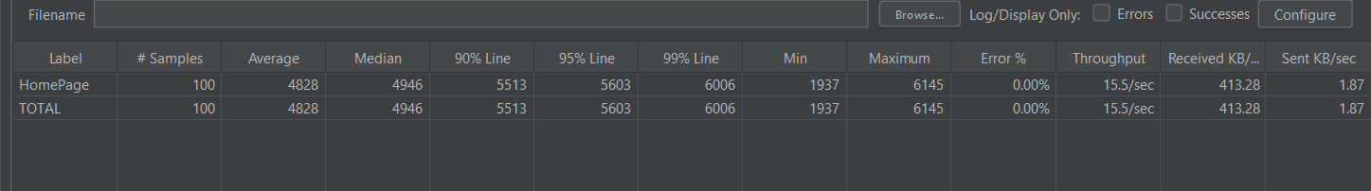

|  |  |  |
| --- | --- | --- |
| Home page | 100 users | 1000 users |
| Error rate (%) | 0% | 57% |
| Average Throughput (Sec) | 15.5 Sec | 20.3 sec |

Dashboard Review

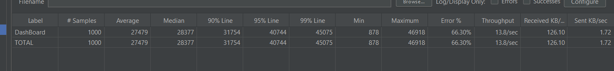

|  |  |  |
| --- | --- | --- |
| Dashboard | 100 users | 1000 users |
| Error rate (%) | 0% | 66.30% |
| Average Throughput (Sec) | 12/sec | 13.8/sec |

About Page review

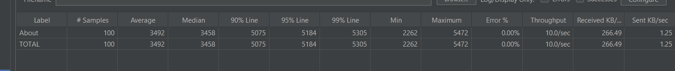

|  |  |  |
| --- | --- | --- |
| About | 100 users | 1000 users |
| Error rate (%) | 0% | 64.30% |
| Average Throughput (Sec) | 10/sec | 10.8/sec |

Overview Page Review

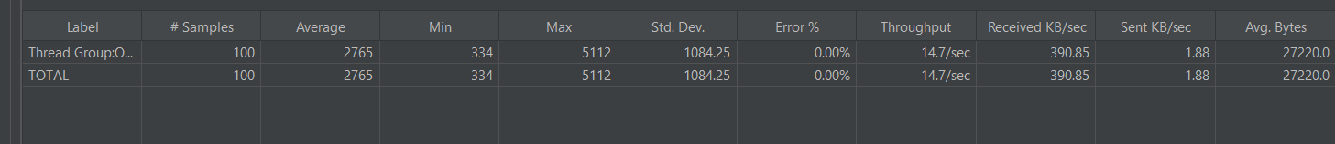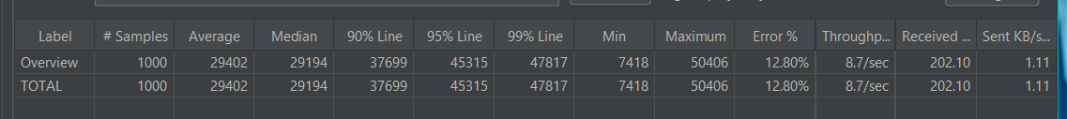

|  |  |  |
| --- | --- | --- |
| Overview | 100 users | 1000 users |
| Error rate (%) | 0% | 12.8% |
| Average Throughput (Sec) | 14.7/sec | 8.7/sec |

Make Play Functionality

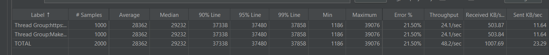

|  |  |  |
| --- | --- | --- |
| Make Play | 100 users | 1000 users |
| Error rate (%) | 0% | 21.50% |
| Average Throughput(Sec) | 20.1/sec | 24.1/sec |